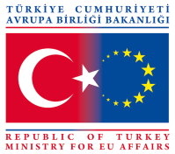
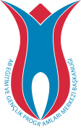
Project summary
Project will be done in Yalova between 9-15 September.

Content/history of the Project:
Young age is the liveliest and most dynamic period in human life.It is a critical period that people have high expectations and also various necessities.In this period,it’s an important gain for youth to give them information that they can use these knowledges now and in the future,at every stage in their life and doing these without restriction of their dynamism and variety.For this reason,we determined young people as the most strategic population for financial literacy to be reinforced in our country.Based on this,our group that is aware of how important is to make savings for young people,wrote this ‘Ayağını Yorganına Göre Uzat’ Project that is about financial literacy and budget keeping towards youth.This project aims to provide youth with an educational opportunity to budget for their individual financial resources and use finance services properly.Their financial experiences that begin by managing the pocket money and bursary, are going to make a great contribution them to manage their own family budget abd firm in the future.
Aims of the Project:
The general aim of our project is to increase the level of financial literacy of youth and to raise awareness of them about managing the budget and money.
Our specific aims are as below:
Teaching youth how to manage budget.
To inform people about the points to be considered while they are preparing budget.
To prepare an effective budget and upskill young people to manage money by creating profit and loss account statement .
Providing youth to give the right decision by blocking spending drive with ten second rule.
To teach them the methods of creating a healthy financial future.
Raising awareness of youth about advantages of saving money.
To provide young to become skilful at saving planning.
To get youth adopt managing and saving money habits.
To disseminate the good practices about entrepreneurship and saving among the partner organizations.
Creating awareness of primary education students on saving money.
The number of participants and participants profile:
The participants of this Project are youth.There will be 32 participants from 4 countries (7 young +1 eader from each) and the age-range is 18 to 30.There isn’t age limit for leaders.
Description of the methodology to be used and activities:
Activities:
Acquaintance dinner,adaptation activites,orientation,group meetings,formal opening,informing about the project,group dynamisc,expectation tree and the impending danger activity, expert presentation in order to give general information about financial literacy and budget management,cultural night,What is your suggestion?,discussion,report preparation,Yalova University visit,making piggy banks with Yalova Yusuf Ziya Primary School,preparing poster individualistically and in group,group presentations with good practices in the world,creative drama,project development and presentment,evalution and report preparation,dissemination and project draft preparation activites will be done.
Methodologies to be used:
Group studies, ice breakers,games,energizers,group dynamics games, discussions, presentations, brain blooming, learning by experience,problem analyses,question and answer teaching method,field visit,self-study,drama performance,exhibition and questionnaire methods will be used during the activities.
Expected results and a brief description of the effects:
The Project aims to provide youth to make contribution to sustainable development vy raising awareness of them about to form a healthy financial future.So their awareness about the necessity of saving and budget planning will be heightened.At the same time,numeric and tangible datas about saving and money management will be learned.And as a gain of all these experiences,we are going to ensure that young people be more disposed to gain the habit of saving and budgeting.Participants who increase the knowledge level on these topics are going to be more conscious and contribute to sustainable development process with genarations have a high literacy rate.We also will provide participants to change themselves about expenditures and support their interest in managing money.
Benefits of the Project in a long term:
By creating awareness of youth about to get them adopt a saving habit,we are going to conduce to write new projects and increase the level of financial literacy in society with the project activities conducted.Young people who participate in this project are going to be more conscious consumers that can manage their own life and money,tell request from needs.

ACCOMODATION
Accomodation will be in governmental hotel
http://yalovaogretmenevi.meb.k12.tr/

Yalova is 100 km far from İstanbul. You can directly come to yalova from İstanbul by bus.

ARRIVING IN YALOVA
1) From Atatürk Airport to İstanbul Terminal
Before start your journey, get some Turkish Liras (exchange nearly 20 Euros). Atatürk Airport is in İstanbul on the Europe cape. You can use Metro. It it fastest, cheapest and easiest way to use metro to get to the big İstanbul bus terminal (OTOGAR). The journey should cost around 2,5 .
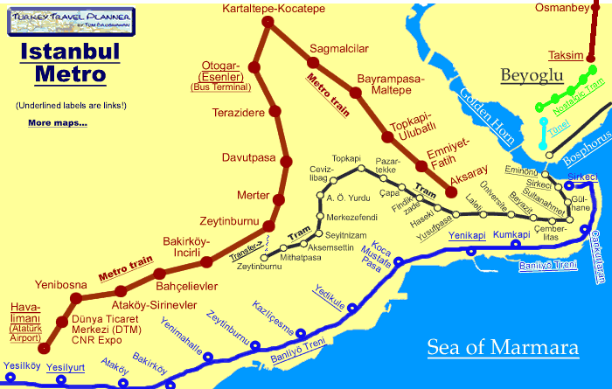

2) From İstanbul Bus Terminal to Yalova
Before coming Turkey, firstly check the time tables of the busses. For İstanbul terminal to Yalova, please find the platforms below where you can buy the ticket for Yalova and also get on the bus. The journey will cost around 40 (nearly 11 euros). Buses are very comfortable with tv special to you. Tea, coffee, cake and water or what else they offer you are free. Don't so amazed to it, here is Turkey. And do not hesitate to get them, bon appetit :)
The travel agencies are;
Lüks Yalova Seyahat
http://www.luksyalovaseyahat.com/
Metro Turizm (there is English version of the site)
https://online.metroturizm.com.tr
ATS Turizm
http://www.atsseyahat.com/

3- Tell driever that, you will go to Yalova Öğretmenevi, they will help you to find midibus that comes to Hotel.

Yalova öğretmenevine gideceğim, hangi minibüse binebilirim? (I will go to Yalova Öğretmenevi, which midibus should i get on?

if you have any other problem, call us and give phone to driver or tell us where you are. At worst, we will take you to hotel.

BUDGET
Hotel and meals will be paid %100, each country will be paid maximum 275 euro for travel.

IMPORTANT NOTES:
1- Do not use taxi, it is not eligible cost.
2-NEVER lose your boarding cards, e-tickets, bus/train tickets. you can not be reimbursed without boarding documents. You will be paid according to the cost on the ticekts.
3- Insurance is not eligible cost. Please make health&travel insurance from your own budget. It is vital for you.
4- There have to be gender balance. All can not be male or female.
5- Prepare some presentations for intercultural night. u can put some pictures about your culture, songs, famous people etc...
6- Bring national drinks, food, national clothes etc... for inter cultural night. But please not only alcohol drinks.
7- Bring photos, newspaper, booklets, brochures etc for NGO fair. you will be given stants and you will tell about your organization to the visitors. Prepare a presentation about your NGO/Group.
8- Total travel cost which can be reimbursed is 170 Euro. Please get the most economical vehicle for travel.

